**Interfaces**  
* An Interface, in Java terms, specifies methods that a particular class that implements the Interface must implement.  
* The Interface itself that you‘re creating is Abstract, and that means there’s no actual code for any of the methods, you only supply the actual method names and the parameters, the actual code still goes in the actual class that you’re creating.  
* But the idea is to use an Interface to provide a common behavior that can be used by several classes by having them all implement the same Interface. So it’s really a way to standardize the way a particular set of classes is used.  
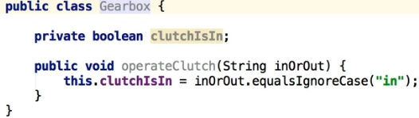  
* That’s just one way of implementing a particular method to decide whether the clutch is in, in a GearBox class. But that’s probably not the best way of doing it. It’s a little bit untidy.  
* So if we wanted to actually do something different, we might decide that we want to actually change this here to a boolean.  
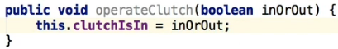  
* That’s certainly valid code and does work, but the problem would be then that the actual signature, in otherwords this component of public method, has been changed. And if you’ve got some other code that is reliant on the fact that this first parameter was a string (that’s what it originally was), it means we’ve broken that other code in the sense that that then has to be changed as well. And if you’re using a very popular framework or your code is used in a lot of other places, this could be a serious problem and it’s not something that becomes immediately aware if other programs are actually using your GearBox class.  
* The problem actually is that although we’ve created this GearBox class, we haven’t really made a sort of commitment that it won’t be changed. In other words we haven’t said that once we create this particular public method, we aren’t going to change it.  
* So what that Interface is is just that. It’s actually a commitment, a contract if you will, that the method’s signatures and that those variables in the Interface, constants if you defined any, will not change.  
* So consequently, you can create an Interface and use it and you’ll know that provided you stick to what’s in that Interface, the code isn’t going to change and you’re not gonna be breaking code anywhere.  
* Let’s now create an Interface to define the behavior of a telephone.  
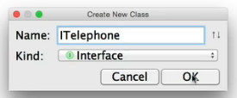  
* **By convention you type I as the first letter**.  
* It’s an Interface, named Telephone.  
* It uses the word **interface** instead of a class.  
* What we want to do is we want to define - just the methods in this case - that are gonna be used in this interface, that a Class that implements this interface, needs to actually implement.  
  
  
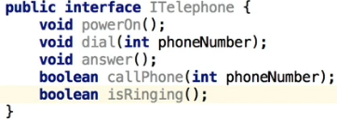  
* I’m creating what’s called the **SIGNATURE**. This is the parameters, the name, the return type.  
* We’re not actually defining the actual code itself. That still goes into the class that inherits this interface.   
* IntelliJ says the public keyword is redundant here and that actually makes sense if you think about it. And that’s because we’re actually implementing the interface in a class, so the interface exists to define the methods that must be implemented. So in other words private or public is really useless, in essence, because you’re gonna be doing that in the actual class. So you don’t need the access modifiers.  
  
* You use the **implements** keyword to use the interface.  
* The error says we need to start implementing some of these things in order for this to become a valid class.   
* So there’s a couple of ways forward:   
1) You can actually do this automatically, you can create the basic methods.  
2) You can create stubs for these methods, which means you can create empty methods and implement these if you want   
3) You can type them manually.  
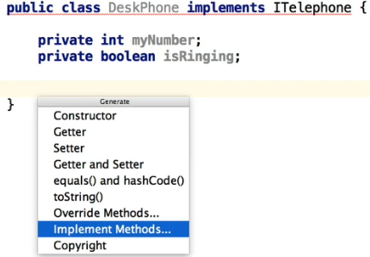   
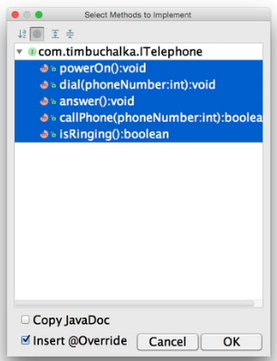

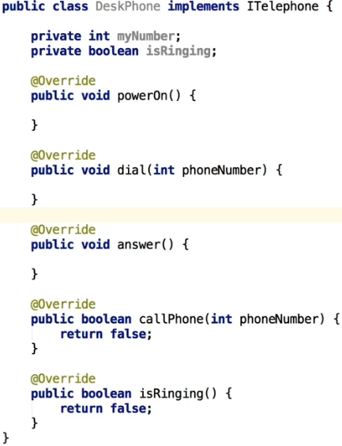  
* Now the error is gone.  
* We can now implement the methods if we want.  
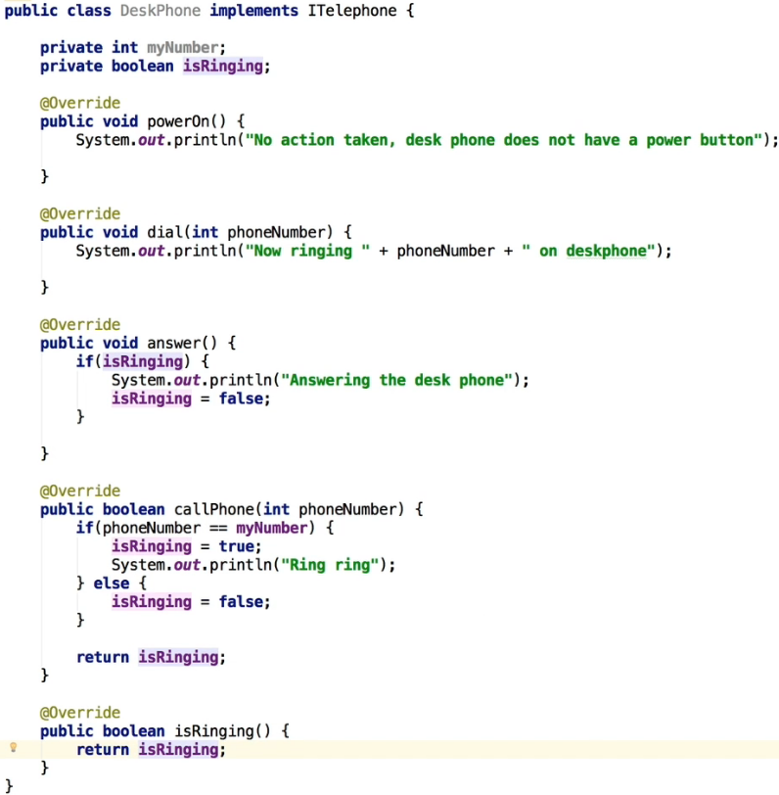  
* In powerOn() you can see how you can deal with methods you don’t need.  
* Let’s also create a constructor.  
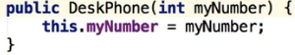

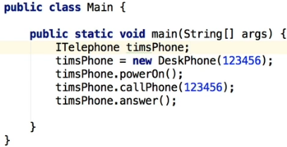  
* You can’t initialize it with ITelephone timsPhone = new ITelephone().  
* The interface is there at an abstract level to tell you what methods are valid and have to be actualy overridden in an actual class. That’s why you can’t instantiate it using the ITelephone interface, you have to use the actual class that has overridden that functionality.   
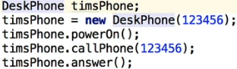  
* We can change the ITelephone to DeskPhone, that’s certainly valid as well and that will work.  
* I’ll show you later why you might need to do that in certain circumstances.

**Interfaces Part 2**  
* You turn MobilePhone on/off as opposed to the DeskPhone.  
 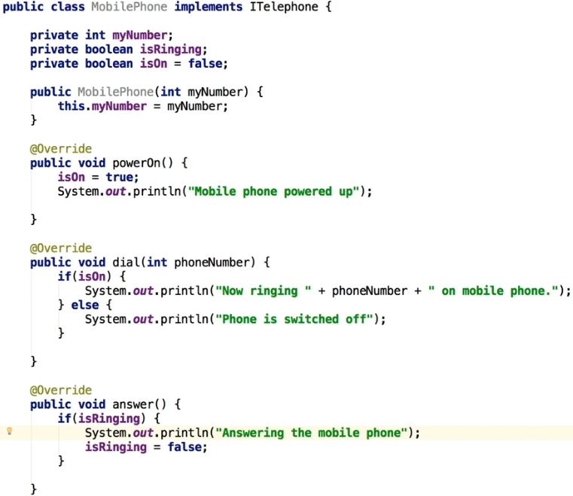  
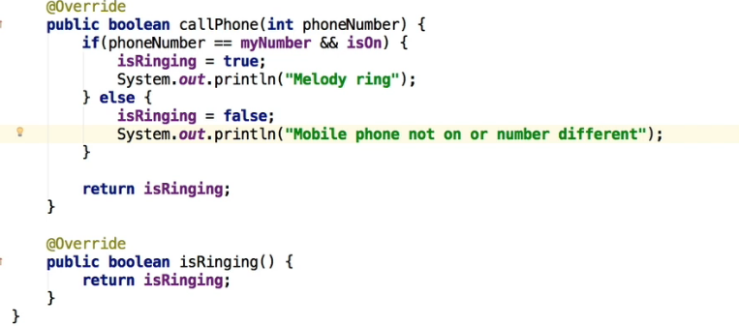

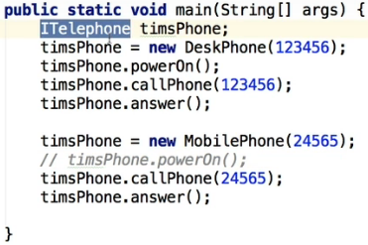  
* **Notice how I was able to set a new instance of MobilePhone as a completely different class, but it still worked. Now, normally, if we had come up here and we actually had assigned that to be of type DeskPhone, then this reassignment wouldn’t have work. We’d get an error because of incompatible types**.  
* But because the type of the Itelephone interface, we’re able to change it and to actually create a new instance of whata is essentially a different object, a different class and it still works and that’s because they both implement the same interface.  
* We’re gonna open the LinkedList file.  
* The reason I’ve opened this code up is just to show you how Java makes extensive use of interfaces, and the one that we used recently is the **List Interface**.  
* We’re gonna go and open the addToPlaylist() method in the Album class and I wanna show you how we can make a change and for it not to actually break anything. The method takes the int trackNumber and LinkedList playList.  
* Because we’re using interfaces, we can change the LinkedList to List and it still works quite nicely.  
(you just need to import that List)  
* But notice how the code is still compatible.   
* If we go back to the main method where it’s calling this code, and make a change, we can run this code virtually without changing anything else because Java libraries are using interfaces extensively.  
* The overloaded method in Album:  
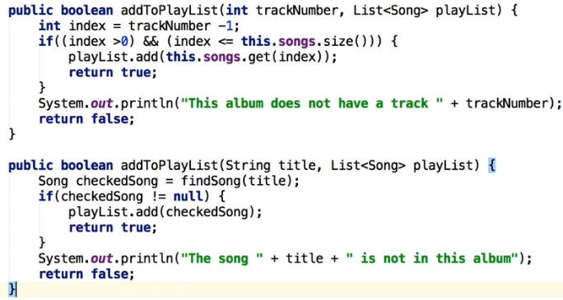  
* We need to change this because it’s hard-coded LinkedList:  
  
  
* And also the declaration of the playList:  
  
* And also where we use the playList:  


* Now it all still works because Java libraries use intefaces extensively.  
* The thing I wanted to point out is that the Java libraries do make extensive usage of interfaces and because they’ve done that, we’re able to change out the entire implementation from what was a LinkedList, to an ArrayList very simply and we’ve actually just done that with a minimal amount of changes.  
* That’s one of the reasons why you’d want to be using an interface. It just makes it a lot easier to make your code work. You can make certain classes interchangable like Java libraries did to LinkedList and List.  
* You can even use another type and the reason that this works is that the contract that’s defined by the List interface, as long as you create a Class that implements these methods and actually creates real methods, creates the code in other words that create that functionality, things are gonna actually work fine and as you can see we’re able to quite easily change the code to make it a generic List but then in the main method where we actually set it up, we created an ArrayList and the playList which was originally a LinkedList, we changed that to an ArrayList.   
* And because the ArrayList which implements the base List interface, it’s still using and supporting all the methods, it has to have implemented those methods. That’s really the power of an interface.  
* Java is using interfaces a lot internally.  
* We can also change the playList to a Vector. Vector is another type of List and the code still works and it’s not broken.  
  
* So it’s very normal when you’re creating lists in your code, to define the basic type of type List and then when you actually initialize the variable, that’s when you actually specify the actual type.  
* **So it’s probably a good habit to get into, to make your lists use a generic List as the type and then you just specify the actual type that you want in your program when you initialize it**.  
* In terms of deciding whether to implement an interface or inherit from a base Class, sometimes it can be a little bit difficult to decide which one to do.  
* In other words should you create a class and extend from that? In other words inherit from that Class or should you use an interface?  
* We could have had the telephones extend Telephone but in this particular case, it probably wouldn’t have been a good approach.  
=> So the way to decide that generally is to really consider the relationship of the final class to the object that it’s extending or implementing. So in other words with our Telephone example both devices have a Telephone, the DeskPhone doesn’t have anything else but the MobilePhone is not just a phone despite its name because of course, a modern mobile phone has more computing power than a desktop computer 15 years ago. I mean, it really can do far more than make or receive phone calls, **so it’s more accurate to say that a MobilePhone is actually a computer that has a Telephone intereface**. So you can say that a DeskPhone can telephone and a MobilePhone can telephone, which indicates that they should both implement a telephone interface rather than extending a telephone class.  
* The other thing that’s important to understand is that a class can only inherit from 1 super Class, unlike other languages like C++ where you can do that.  
* **But you CAN actually implement from many interfaces**.  
* This is something that’s quite powerful.  
* In Java, multiple inheritance is only available by implementing several interfaces.  
* If you want another example:  
=> Consider the Animal class that we created. Not all animals can walk, so we cannot put a walk() method in the animal base class. But we could define, say, a **IWalk** **interface** though. So if that was the case, we could then consider Birds. They can walk() and most of them can also fly(). So we can create a **IFly** **interface** as well.   
**A Dog would extend Animal and implement IWalk**.  
**A Bird would extend Animal and implement both IWalk and IFly interfaces**.  
* **So in this case, a Dog is an Animal and a Bird is an Animal so they both inherit from the Animal class. But a Dog can walk() so it implements IWalk and a Bird can both walk() and fly() so that would implement from both IWalk and IFly interfaces**.  
* So I hope that’s clarified, there’s an important distinction there.  
* And again the way you decide is to really consider the relationship of the final class to the object that you’re extending or implementing.

**Interfaces Challenge Part 1**  
* To simulate getting values from a file:  
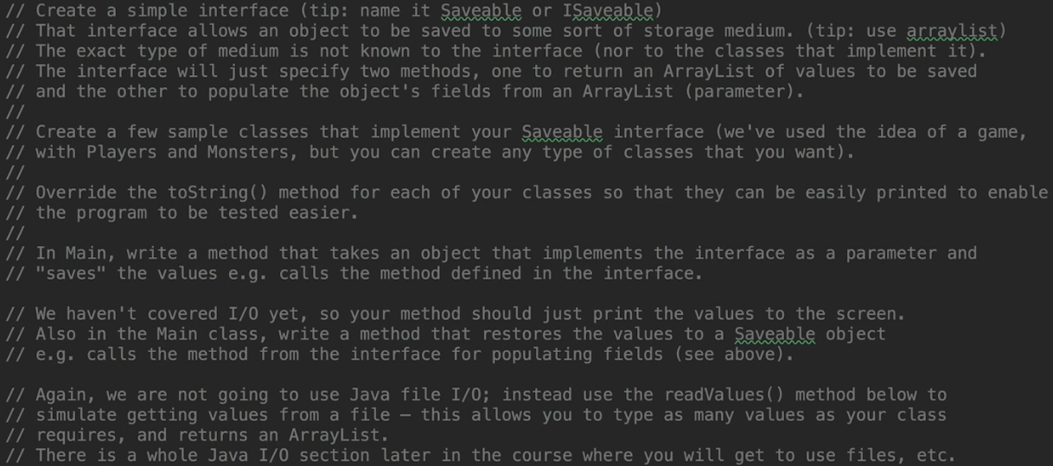  
  
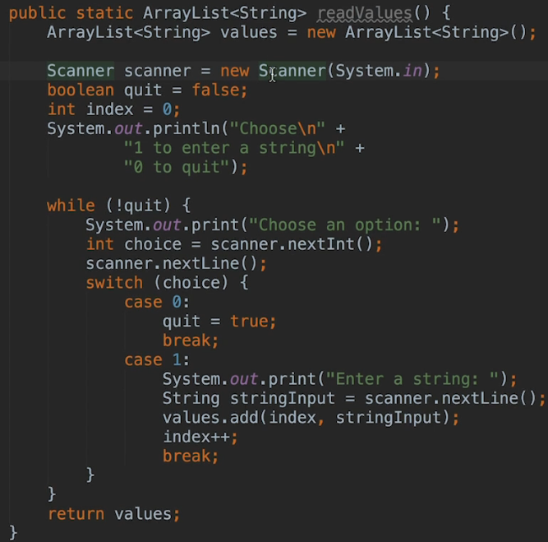  
  
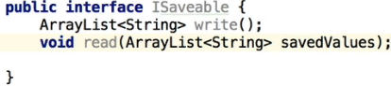

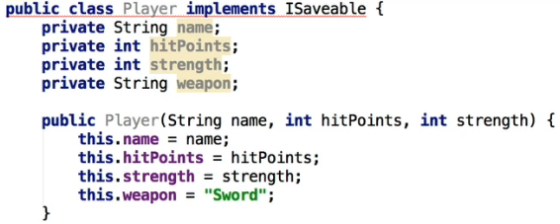  
 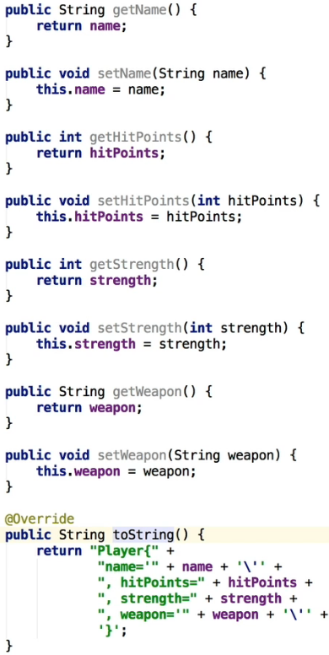  
* **The @override we can leave as IntelliJ gives us as the default**.  
* **Implement methods => select both (for the interface)**:  
  
* The write() method is going to just insert the values of all the members that are needed to save the state of our Player into the ArrayList and then return it. So any variable that is not a string, will need to be cast to string.  
* The read() method is gonna receive an ArrayList containing the values that have been previously written by the write() method and use them to recreate the state of all the member variables.  
* So any values for non-string members also have to be cast to the appropriate type.

* We’re just gonna use the generic interface List whenever we’re using a list of any type. Thanks to that we only need to change it in one spot here:  
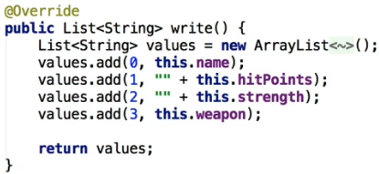  
* Now we can use any type of list, we don’t have to use a specific one.  
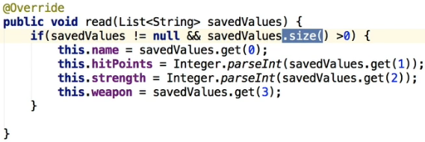  
* Because we use methods that are in a List, even if we have an ArrayList passed, it’ll still work because it implements them as well.  
* We’ll do the same for the interface, for maximum flexibility:  
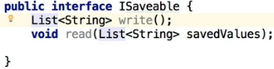  
* Main.java:  
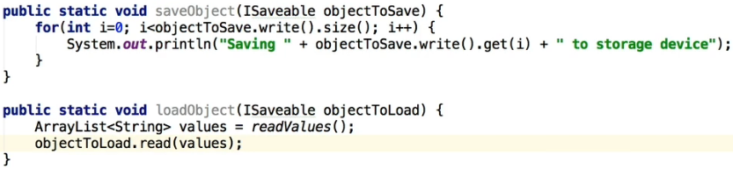  
* By passing the ISaveable as a parameter, we’re using the ISaveable interface and by doing that, we can use any object that is using this interface, that has implemented this interface. So we can be quite generic, we can use this method for saving any type of class, which is very powerful.  
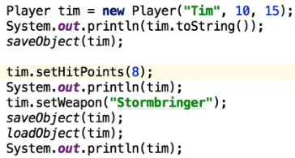  
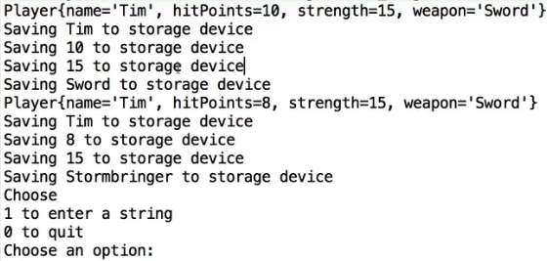

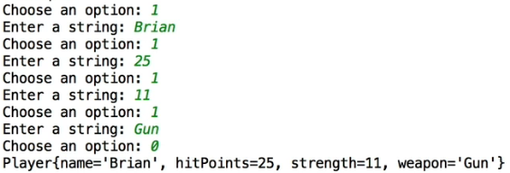

**Interfaces Challenge Part 2**  
* The .toString() that we override is the “String concat (+)”.  
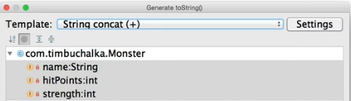  
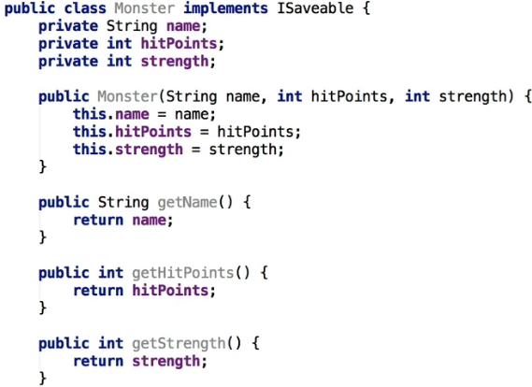  
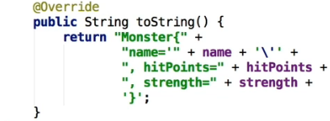  
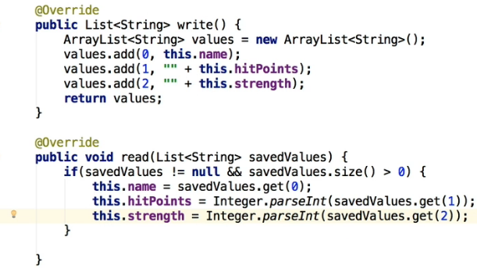

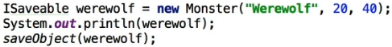  
  
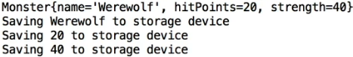  
* You can see that there are obvious advantages to this ISaveable Interface in that we’re guaranteeing what’s a contract to confirm that if a class is implementing this interface, it has to implement that code. So it’s a way for you to make sure that those particular methods are overridden so that the actual functionality that is needed for that class is actually written, and if.

* What we CAN’T really do is:  
  
* We have a getter for strength in the Monster class but it’s not working.  
=> To make it work and use that method which is specific to the Monster class, we have to cast it:  
  
* That’s how to get around the fact that you declared it as an Interface.

* **Whether to declare it as the Interface or the Class, generally speaking, depends on what you’re going to do with the instance. So if you wanted to declare a variable that can hold objects of different types, then it would have to be the type of the common interface. But if you want to access methods that exist in the Class like we wanted to do above, then the object will have to be declared as the Class type itself unless you wanna get around it by using a cast**.

* **Generally speaking, where there’s no strong reason for using the Class type, so in our case there isn’t really a strong need for us to use the Monster class type, because we’ve got these generic methods for reading and writing, and we can access those in a similar way. So that being the case, generally you’ll probably wanna declare it using the interface and that really is ideal anyway because it keeps your code more generic and makes sure you’re getting the best out of using the interfaces. You can always cast the instance to the class type if necessary.** Also notice that parameters to methods that have been declared as the interface type, are automatically cast from the class type for us, so Java does some of that work for you.

**Inner Classes Part 1**  
* **In Java it’s possible to nest a class inside another class**.  
* There are 4 types of nested classes that you can use:  
1) **Static Nested Class**=> Used mainly to associate a class with its outer class. In terms of behavior you can thinkof it as being indentical to a top level class, but the difference is that it’s packaged in its outer class rather than in the package. That really means that it cannot access the non-static methods or members of its outer class without first creating an instance of that class.2) **Inner Class** (**Non-static Nested Class**)  
3) **Local Class** (**Inner class that’s defined inside of a scope block, usually a method**)  
4) **Anonymous Class** (**Nested class without a class name**)  
* We’ll start with an Inner Class because these are quite useful and the reason they’re useful is when it doesn’t make sense to refer to a class without its outer class.

* Example: if we’re modeling an engine, we might have a Gearbox class and a Gear class.   
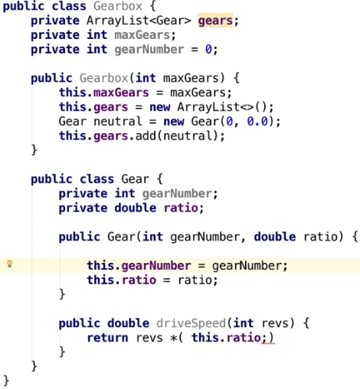  
* So it doesn’t actually make sense to refer to a Gear in this scenario, except when we’re talking about a Gearbox. So the Gear isn’t something that sort of useful in its own right, it’s coupled with a Gearbox so it makes it useful. So that’s the idea of using an inner class - when it doesn’t make sense to refer to something except within the context. In this case, it doesn’t make sense to talk about Gears unless it’s within the context of a Gearbox.  
* **Instances of the Gear class have access to all the methods and fields of the outer Gearbox class, even those mark as private**. So notice that the use of **this** in the Inner Class refers to the Inner Class and not the outer one. In other words the this.gearNumber is actually talking about this actual Gear class, the Inner Class, not to the outer Gearbox class.  
* **If you want to refer to the Gearbox’s gearNumber from an instance of the Gear class, you have to use Gearbox.this.gearNumber**.  
* If a variable/parameter name is the same as the one that’s in the outer class, it’s said to **SHADOW** the declaration in the outer class. **So about the gearNumber in the Gear class we can actually say that it’s SHADOWING gearNumber in the Gearbox class**.   
* **That’s not a good thing so we’re gonna rename it, to avoid confusion because obviously, you wanna make things as easy as possible when you’re developing. And anything you can do to reduce this sort of confusion, particularly when you start dealing with Inner Classes, it’s very important to do that.**  
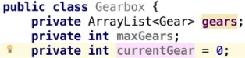  
* The Gear class itself is a member of Gearbox and it must be created within instance of it.  
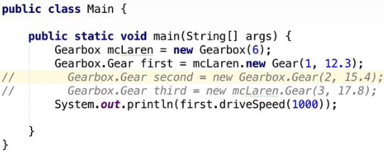  


* The syntax might seem a bit unusual but that’s just the way that the designers of Java have implemented this.  
* **Another thing to keep in mind is that often though the Inner Class is gonna be private anyway, in other words, instances will only be created by the outer class, so you wouldn’t normally want people to access it directly anyway**. The instance is gonna be created by the outer class. So making this class Gear private makes sense here because we’re not interested in the individual Gear objects we’re driving, we wanna change the Gear but we do that by interacting with the Gearbox, not with the individual Gears. In other words you public interface that you’re exposing to your program here, would be Gearbox, you wouldn’t be exposing Gear directly, you’d be exposing the fact that you can change Gears but you won’t be interacting with the Gears themselves.  
* In Gearbox we create a Gear in the constructor and that’s how we can access that.  
* Now let’s change it to private.  
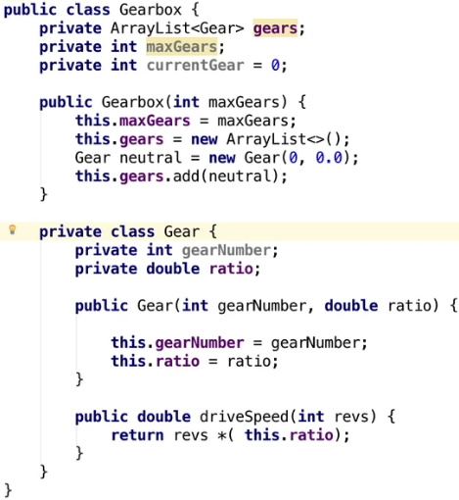  
* We can’t access it directly like we did in the Main.java anymore.  
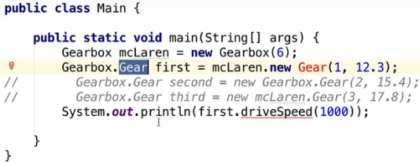  
* We’ll need to make some changes to the Gearbox to do that:  
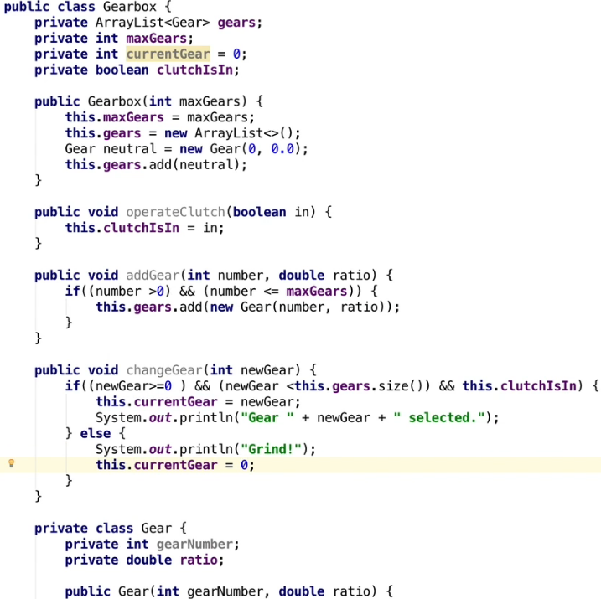  
* Let’s also create this:  
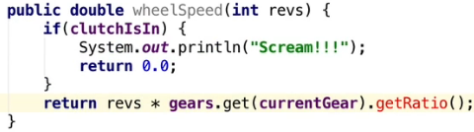  
* And exponse the .getRatio() method:  
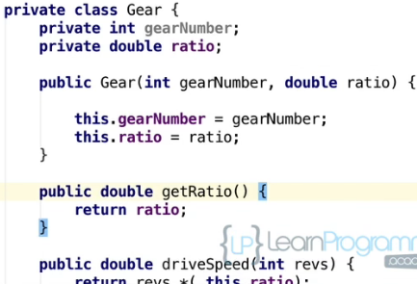  
* Now we’ve written the Gearbox class to perform all the functionality it needs in the Gear class itself, we’re creating new instances of the Gear and saving it in our ArrayList and we’re also using various functions within the Gear to get the ratio and for other sorts of calculations.

**Inner Classes Part 2**  
* Now we need to change the code in our Main.java for it to work.  
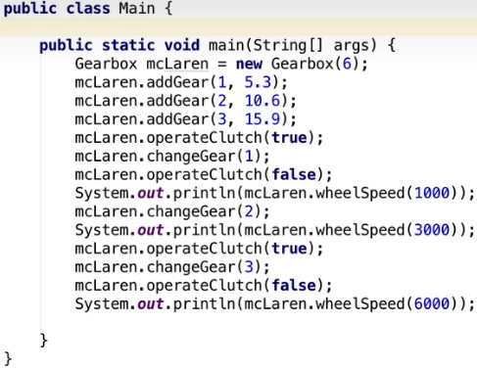 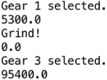  
* You can see we don’t have any references to the Gear class and that’s because the Gear class is like local to that Gearbox class itself now.  
* Also here you can see that really the addGear() calls are really part of building the Gearbox and not actually using it. Therefore, you could consider that it’d be better to put them in the constructor of our Gearbox class rather than actually having them as separate calls:  
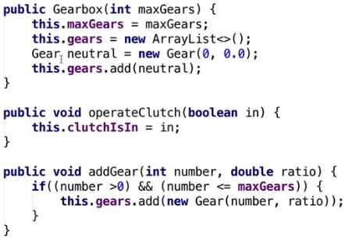  
=>  
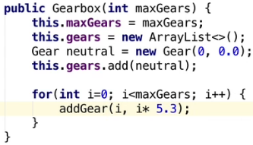  
* Adding the private Inner Class can really be a good way to improve Encapsulation, so objects only know about other objects that they need to know about. In this particular example, nothing apart from the Gearbox needs to have any details about the actual Gear, so we hide the Gear class completely by making it a private Inner Class of the Gearbox class, so you’re not accessing the Gear class at all in anything other than the actual Gearbox class itself. That’s really a great way to encapsulate that functionality and to restrict other people from accessing it.  
* Now obviously if we’re writing a stock control program, then the program would have to have some knowledge of the different gears so they could be ordered or requested to a manufacturer to make them for example. So you really need to decide how your programs should be designed to work. Figuring out how to do that, that’s really the great skill of OOP.  
* There are 2 special cases of Inner Class:  
* **Local** **Class**.  
=> Local classes are declared inside a block, such as a method or an IF statement and their scope is restricted completely to that particular block, so unlike Anonymous classes which can be very useful and we’re going to be seeing them shortly, these Local Classes are used less often. Theoretically you could argue that they increase Encapsulation because they’re already declared within the block that uses them, but in practice, you probably won’t often need to or want to use one.  
=> One example that might be useful is as a comparator, when trying to sort objects.  
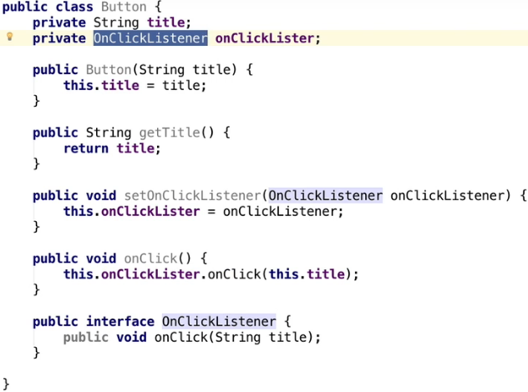  
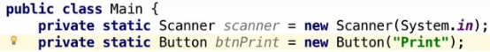  
* At this point we can now create a Local Class that implements that onClickListener interface and assign an instance of it to our button.  
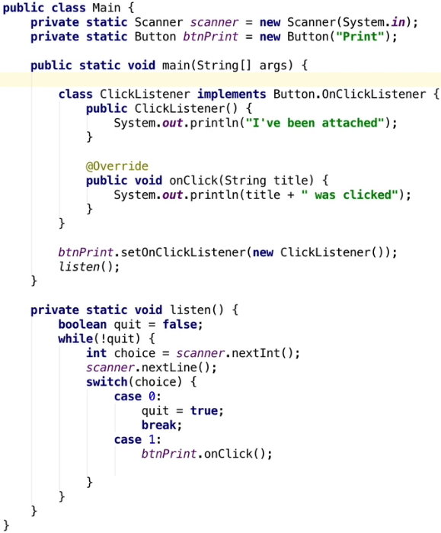 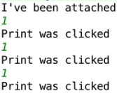  
* At this point normally what would happen is assuming that we’re using some sort of graphic framework, that woul actually automatically respond when a button was clicked and the onClick method would actually be invoked for us. But since we don’t have a graphic framework, we’re gonna use a keyboard to simulate that.  
* The main thing to notice here is with the Local Class how it’s defined is applicable just for that block only.  
=> So this particular method using a Local Class could probably be pretty useful if you want to assign exactly the same object, let’s say to several buttons if you had several buttons on the screen at the same time, for example. The class is not used anywhere, so making it Local in this scenario makes sense because we’re not using it in a shared environment or anywhere else.  
* **Anonymous** **Class**.  
* An Anonymous Class is also a local class, but it has no name. They have to be declared and instantiated at the same time because they don’t have a name and they’re used when a Local Class is required only once. This might sound like it’s of even less use than the Local Class but in fact **they’re very common for attaching event handlers to buttons in a user interface**. For example if you’re programming Android apps.  
* That’s quite likely if we do have several buttons that each would require a different onClick() method so using a Local Class might not be the best solution. In other words if you’ve got 4 or 5 buttons on the screen, chances are you don’t want the exact same functionality to be called each time that button is clicked. For example one button might be to quit the program, another one to print something. So the code to actually execute might be different depending on the button. This is where an anonymous class can come into use or can be quite handy, because what we could do in that example is, rather than define a class for each button, we could use an Anonymous Inner Class to declare an object and assign it to a button, in 1 expression.  
  
=> If you press this, IntelliJ will create the anonymous class for us.  
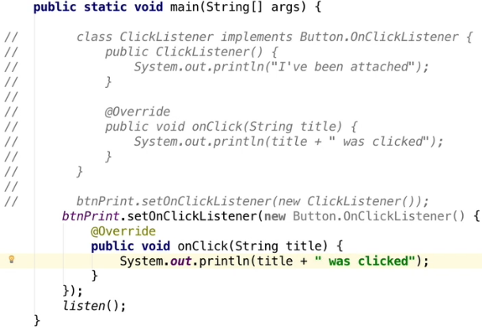  
* If we run it, it’ll work the same.  
* The main difference is we’re not creating a separate class. There is no name because it’s been implemented there and then within the brackets.

**Inner Class Challenge**  
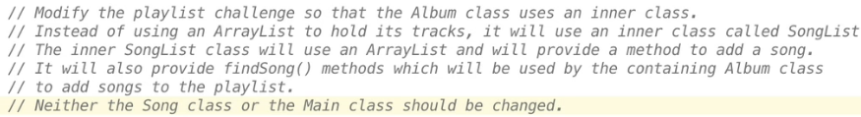  
* There’s gonna be a mistake in the video (it’s the LinkedList challenge mistake):  
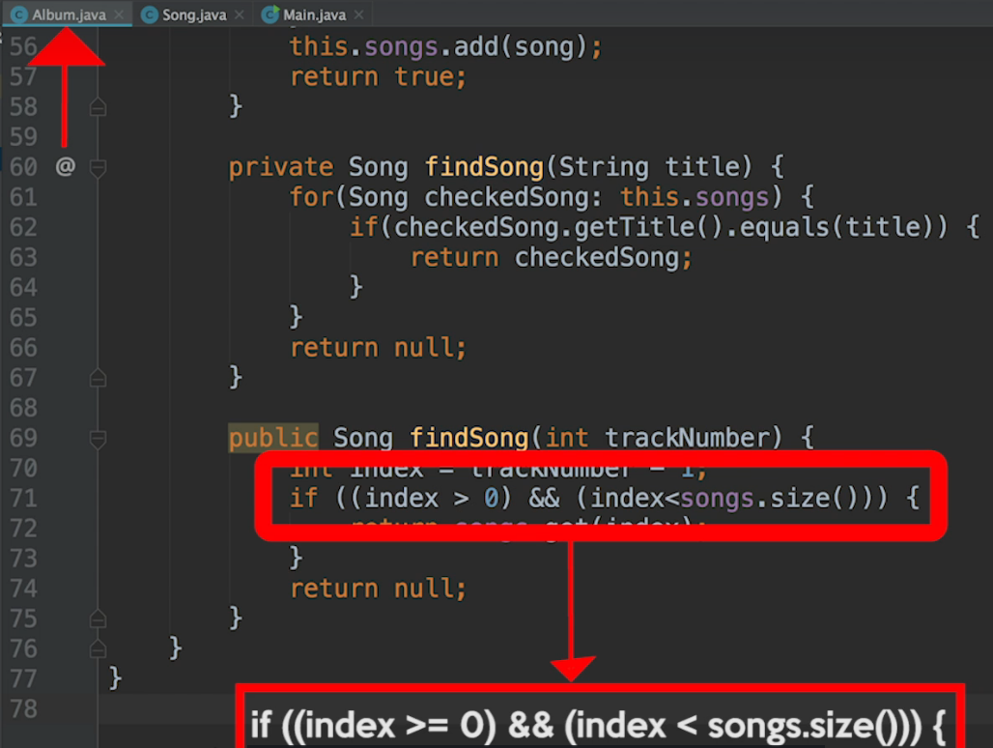  
* **Album.java:**  
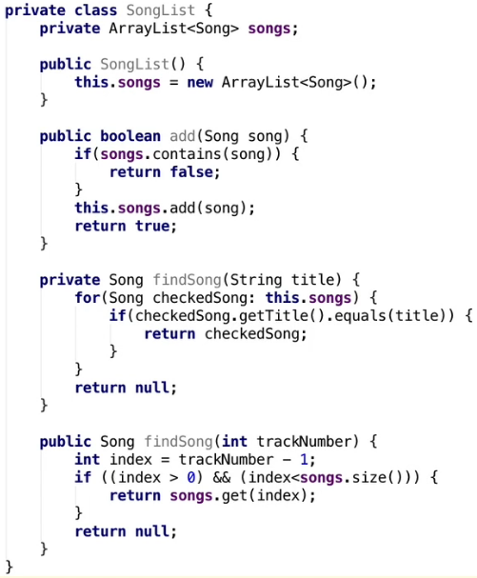  
* Now let’s make changes to the Album class to start using this inner class, this songList.  
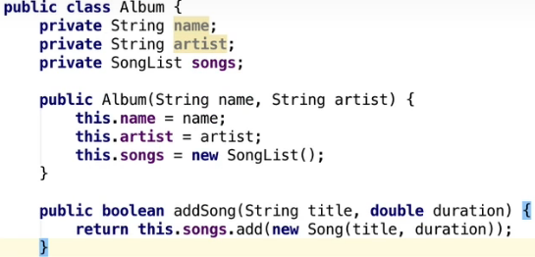  
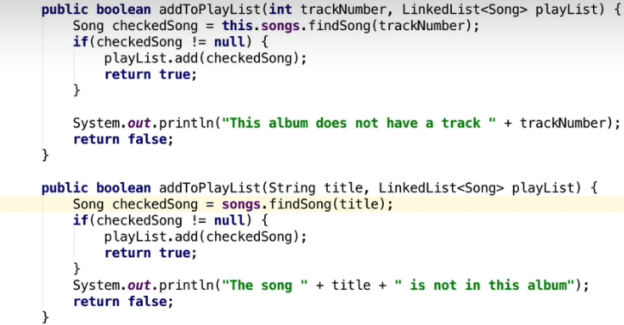  
* The same methods are still applicable in Main.java, it’s still there and we’re still calling those. It’s just all the functionality has changed internally and the main methods has no understanding or concept of the fact that we’re now using an inner class instead of the ArrayList in the Album class. And tha’ts one of the beauties about creating things properly the first time - we can make these changes internally without affecting any other part of the application.

**Abstract Classes Part 1**  
* Abstraction is when you define the required functionality for something without actually implementing the details. In other words we’re focusing on what needs to be done, not on how it has to be done.  
* Interfaces, as you saw, are purely abstract and they don’t specify any actual aspec of the implementation.  
=> **Interface defines WHAT needs to be done, NOT HOW it needs to be done**.  
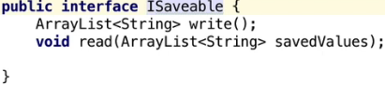  
* **If you wanted to, you could set it up so that each class that implemented this interface might do completely different things with the write() and read() methods**.  
* But strictly speaking, if you look at this interface, it’s not complete abstraction. And the reason is in this particular case there’s a specification that ArrayLists must be used but in a typed language like Java, it’s hard to avoid doing that sometimes. But in this particular case we can abstract this and use just a List. So what we can do is change the ArrayList to just a List. By doing that, we abstracted again because we then didn’t force the Monster class or the Player class or any other class that implemented this interface, to have to use an ArrayList. They could use any type of list for that matter. And that can be really useful and my recommendation is that you should do that whenever you’re using a List of some type in your programs. Generally speaking in terms of the declaration, it’s good to write it like that and that leaves your implementation open to use any type of List.

* Obviously by definition, being an interface is abstract, so you can’t use a new ISavable or a new List. What you need to do is to instantiate a class that implements the interface. And you obviously saw that in the interface challenge.  
* Java also allows abstract classes.  
* Before we get into that, I just want to mention that with this interface we could’ve actually taken it one step further because we specified the type to be a String in the List. But if you wanted to be really flexible, we could even remove that and make that a really generic List and left that open to the user of the class that implemented this interface, to actually decide what type to use.  
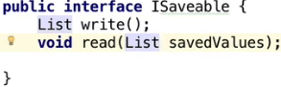  
* This is maximum flexibility.  
* But sometimes there’s a bit of a fine line as to how generic you make it and how specific.   
* Sometimes, somewhere just in the middle might be the way to go.  
* So as I mentioned, interfaces are by definition abstract in Java. So you can’t use the new ISavable or new List, you have to instantiate a class that implements the interface.  
* **Abstract** **Classes** => there are classes that define methods, but do not provide an implementation of these methods. The implementation itself is left to the classes that inherit from the abstract class, so this is different from inheriting from an interface, you can also inherit from an actual class as well.  
* **abstract** **(class or method)**  
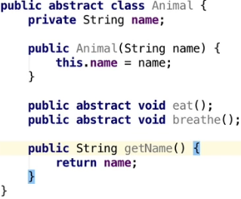  
* We’re gonna inherit from this abstract class and it’s gonna let us define behaviors that are necessary without specifying how they are to be performed. And this really ensures that the subclasses, such as the Dog, must actually implement them, because of course, normally in the normal class, if you’re extending from a class, you can create a base method in the class but there’s no requirement for the other class - the class that is subclassing - to actually implement those methods.  
* **But by creating abstract methods, we actually are forcing the class that is ultimately gonna implement from this abstract class, to create those methods for us. That’s why we marked it as abstract**.  
* The other methods and the other field in this case are quite okay, and they work as normal Java code, but we’re actually specifying and saying there’s some abstract methods here that have to be implemented.  
* **If you refer back to the inheritance videos, you can see it’s very similar to that. Really the only different is we’ve actually marked the class as abstract and included those abstract methods as well**.

* Now let’s create a Dog class.  
* You can see these icons when we try to override methods are a bit different for the abstract ones:  
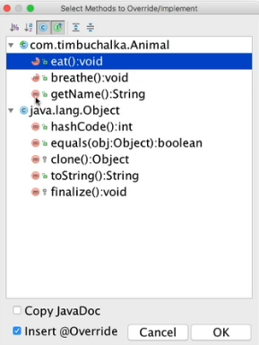  
* That’s IntelliJ’s way of telling you that this is an abstract method.  
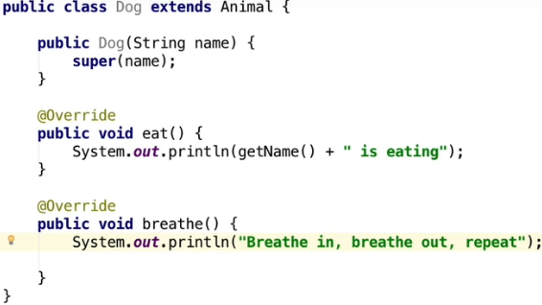  
* The getName() method is inherited from the Animal class.  
* The important thing here is that not all methods have to be abstract. This is one of the differences between an abstract class and an interface, you can actually mix these up in an abstract class. Interface is completely abstract and there’s no implementation whatsoever so there’s no opportunity for us to enter fields, there wasn’t any opportunity for us to enter any other code. We were able just to specify the methods that were gonna be used for that interface that a class that was implementing the particular interface had to fulfill in order to make it valid.  
* **But in case of an abstract class, you can mix it up - you can add fields, you can add regular methods or a constructor, and you can also specify that certain methods are abstract**.  
* Let’s take this now to the next step and create another class - Bird:  
* Birds can also fly, so it could be a good idea to add a fly() method. But not all birds can fly, so implementing a fly() method in the Bird class is not a good idea.  
=> Better idea would be to create an abstract Bird class that extends Animal and also has an abstract fly() method that individual Bird objects can implement as they’re able to.  
  
  
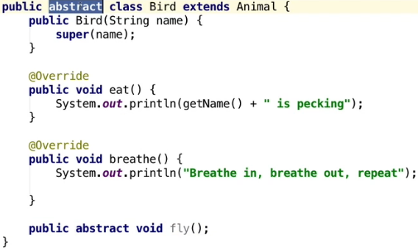  
* It’s an abstract class that’s extending from another abstract class. It’s implementing the required methods that the Animal class requires it to, but it’s also defininf an abstract method fly() that ultimately has to be overriden by another class as well.  
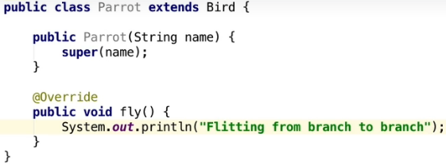  
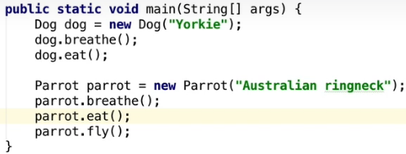   
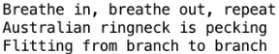

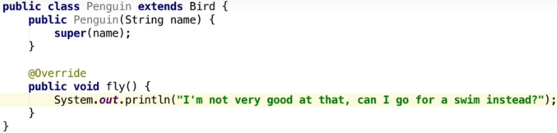

**Abstract Classes Part 2**  
* What is the difference between using an abstract class and an interface and how do you actually go about deciding which one to use?  
* We need to consider the relationships, the relationships IS-A / HAS-A / CAN.   
* **Example: a Dog IS-A animal, a Bird IS-A animal. So it makes sense to inherit from an Animal class rather than implementing an animal interface**.  
* Example: a Parrot IS-A Bird so you can inherit from a Bird base class. There’s a problem with this example though. If you think about it, birds aren’t the only animals that can fly. Bats or dragonflies are extremely good at it for example, but they’re not birds though. To get around that we could rename our Bird class FlyingAnimals and have Bat and Bird both inherit from that. But it should be easy to see the problems that could potentially cause. Bats give birth to young rather than laying eggs. This may lead to having FlyingAnimals being inherited by classes called Mammals and Birds. But not all animals can fly and you can see we rapidly start to run into difficulties. All because we actually got it wrong at the BASE LEVEL.  
* **Where we went wrong here was putting the fly() method in the Bird class. A Bird can fly and a Bat can fly, so a better design would be to have created a CanFly interface, which both Bats and Birds can implement**.  
* The naming convention to add I in front of an interface was to make it easy to identify but nowadays with IntelliJ you see there’s a green symbol with I next to the file so you don’t really have to do it.  
* **So it’s probably better to not put the I there because in many cases it’s just adding extra sort of fluff to your code**.  
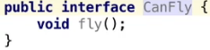  
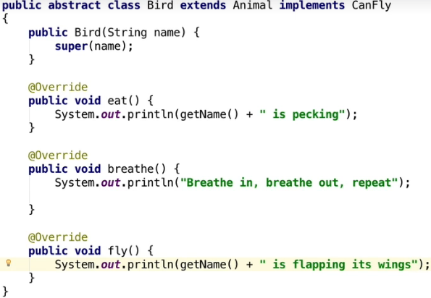  
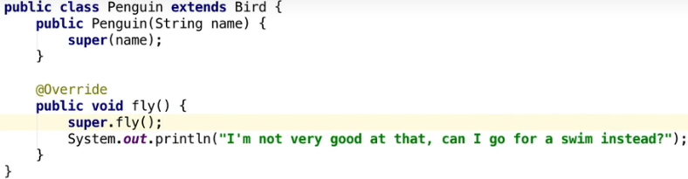  
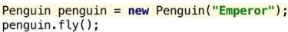  
  
* **The argument for leaving the super.fly() in for the Penguin is that the Penguin has actually got those little wings that it can flap, but obviously it can’t actually fly, it doesn’t get very far**.  
* We can now have a Bat and a Dragonfly classes and inherit from a suitable base class and both could then implement the CanFly interface.  
* You can see that by adding the interface in this case, we’re actually adding more flexibility into the design to enable us to create other classes and we’re not gonna fall victim to the potential problems you would have had trying to get everything to fit into the one class as we did earlier.  
* **You might argue that an animal CAN breath and CAN eat, that they should be implemented as interfaces. And absolutely that could work. But as these methods are really common to all animals, it makes sense to include them in the base abstract class and let later classes implement them**.  
* In other words a Fish would implement breath() differently to a Dog, so they remain as abstract methods.  
* So it really comes down to each sort of function of your class, as to deciding whether you create an interface for it or whether it should be an abstract method as it is here for the eat() and breathe() methods.  
=> To summarize the differences between an abstract class and an interface:  
* An abstract class can have member variables that are inherited, something that can’t be done in an interface. Abstract classes can have constructors. Abstract classes can have defined methods, i.e. methods with an implementation.  
* Interfaces can have variables but they’re all public static final variables which essentially are gonna be constant values that should never change, with a static scope. They have to be static because non-static variables require an instance, and of course you can’t instantiate an interface. Interfaces also cannot have constructors. All methods of an interface are automatically public whereas the methods of an abstract class can have any visibility. All methods in an interface are abstract, there’s no code in abstract methods, all the actual code has to be written in the class that implements the particular interface.

**Interface vs Abstract Class**  
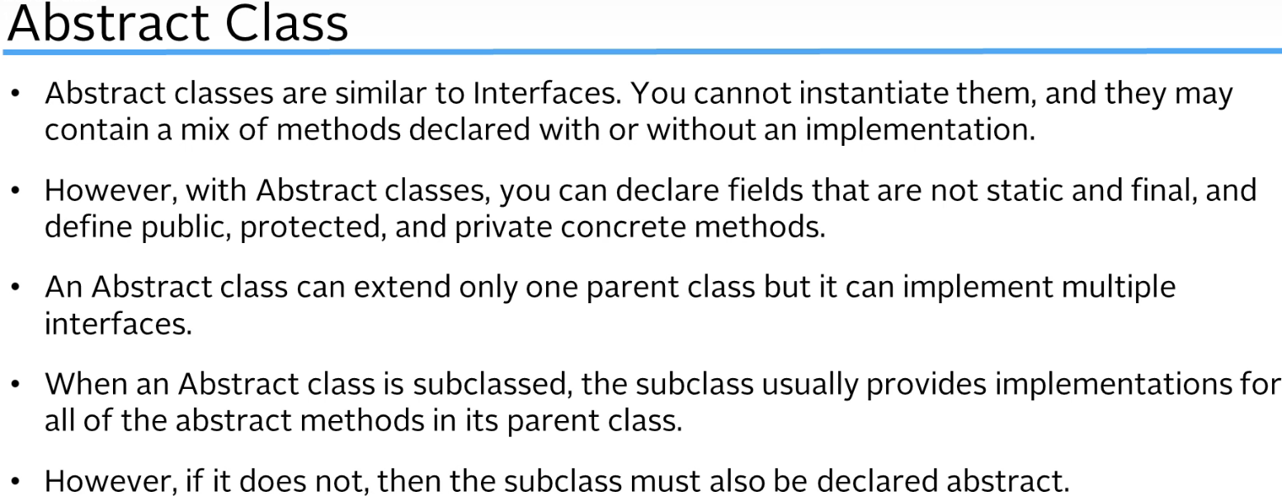

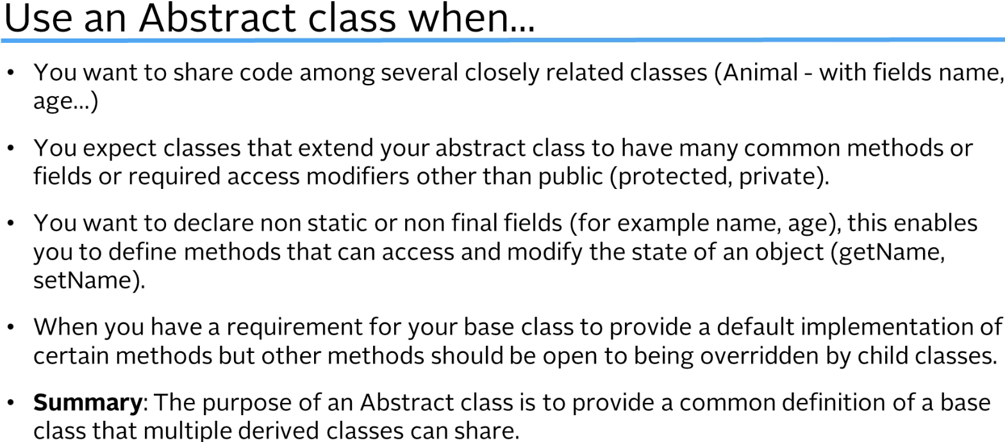

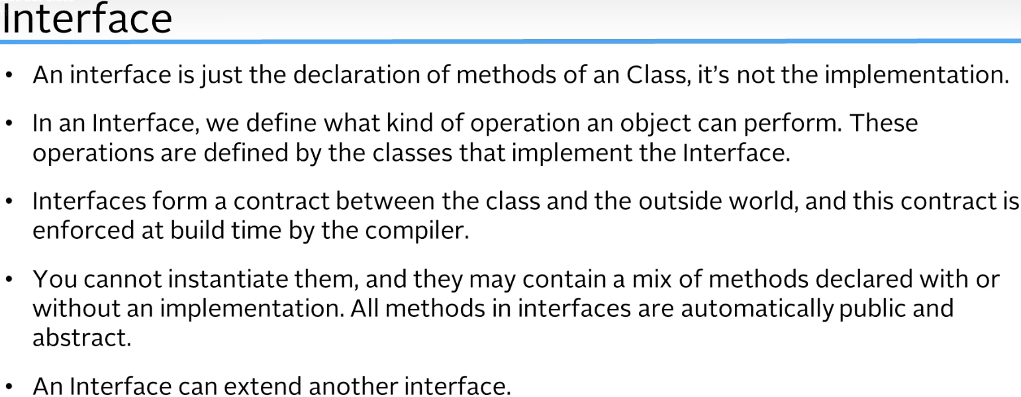

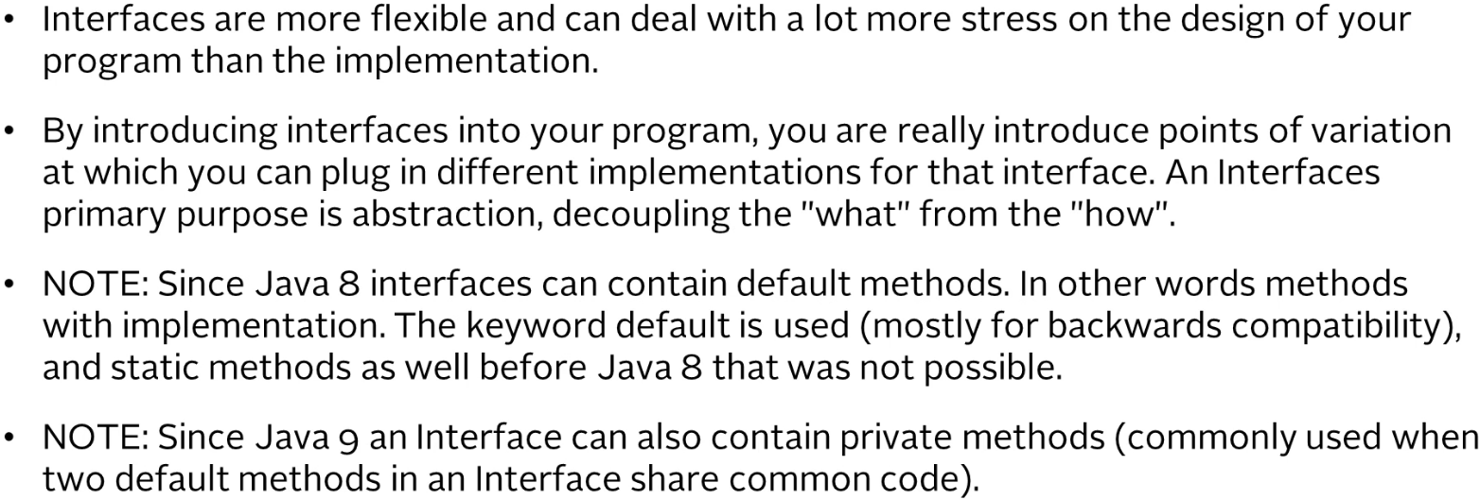

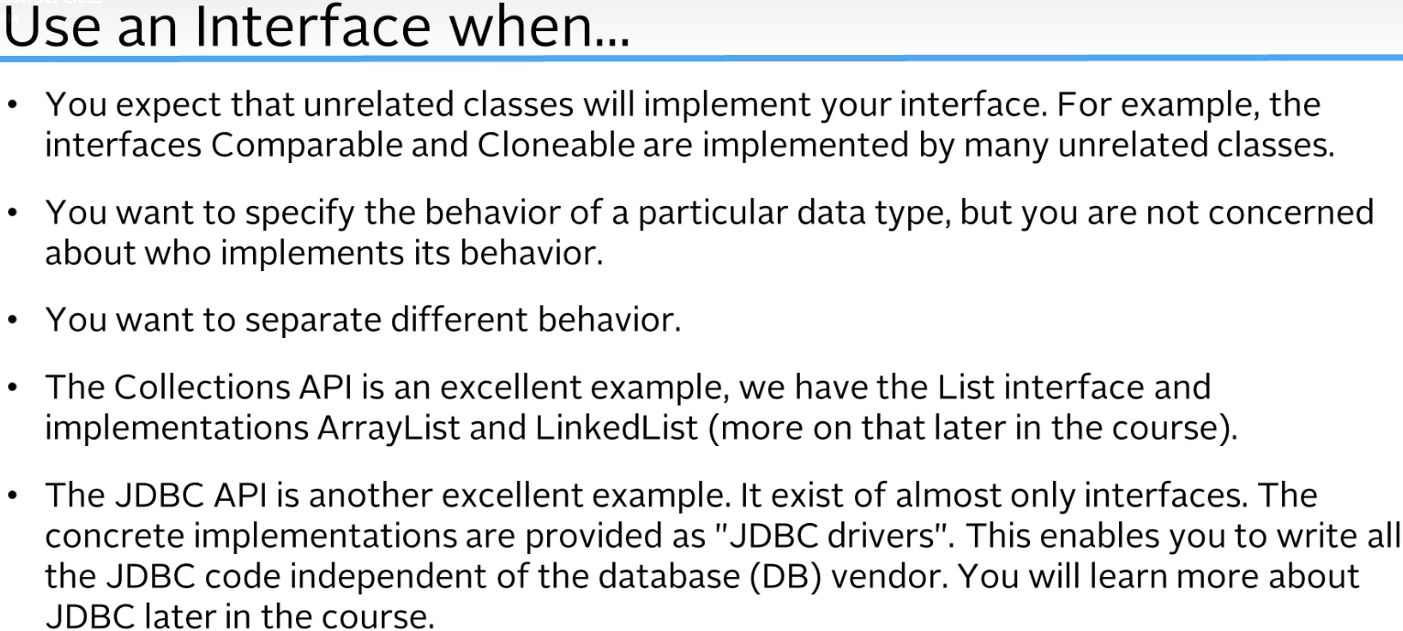

my note: **Interface guarantees that the classes that implement it have certain methods defined, so if you create a method somewhere outside of these classes, that is going to use the instances of those classes, it can use the methods regardless of which class it actually is because both have to have it**.

**Abstract Class Challenge Part 1**  
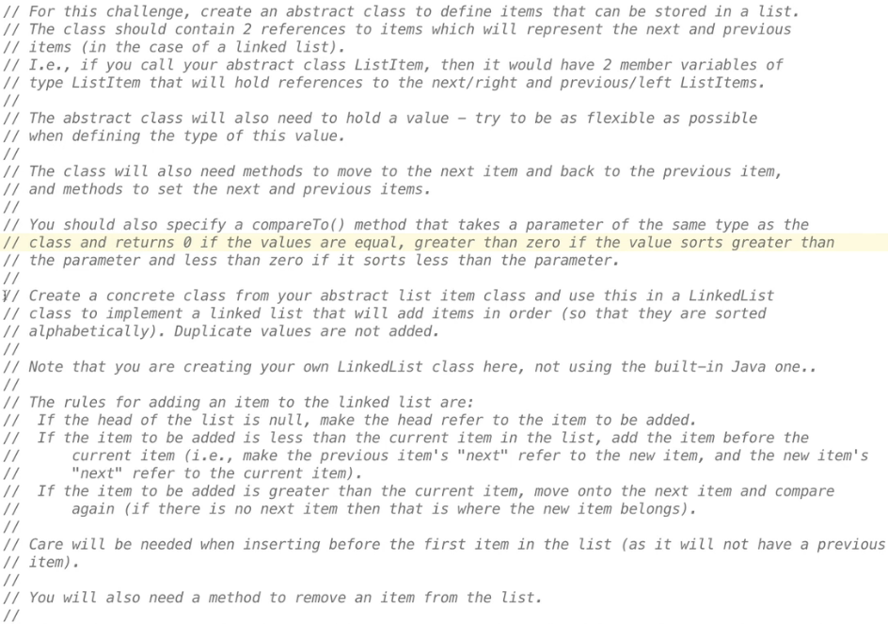  
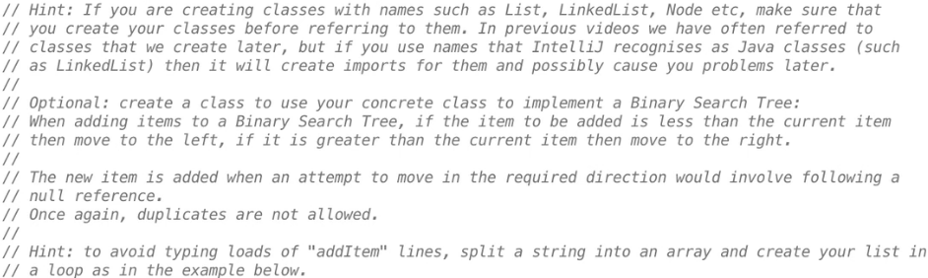

* You’d need to research the Binary Search Trees, they’re very similar to LinkedLists but they’ve got a couple of key difference. If you take up the optional task, you’ll learn a lot in the process.

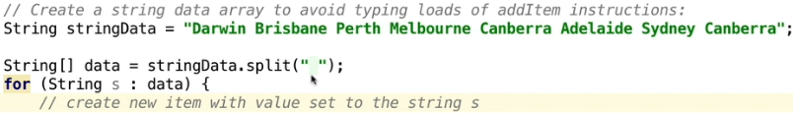

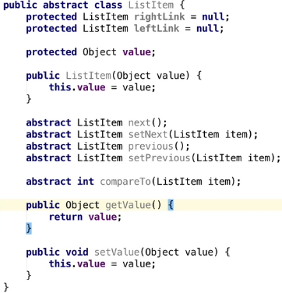  
* By setting a constructor it means that every class that inherits from this class will need to create a constructor that sets the value.  
* **protected** => the reason I’ve declared the fields to be protected rather than private than private is because we need to be able to access them from our concrete subclass. We could’ve left the access modifier off, which would have meant that the member variables are package private so in other words, subclasses in the same package would be able to access them, but not subclasses in other packages, so that’s why we’ve made it protected.  
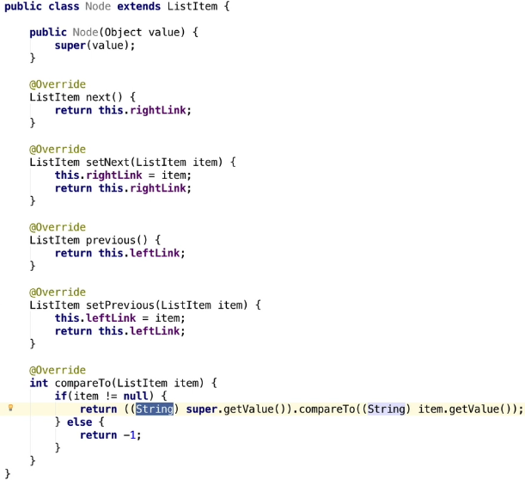  
* **.compareTo()** comes from Strings.

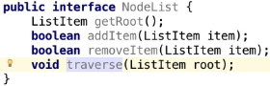

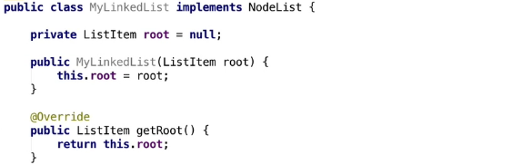  
 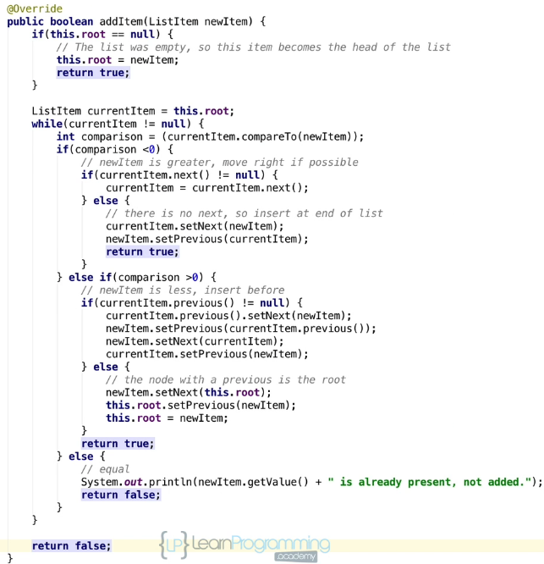

**Abstract Class Challenge Part 2**  
* There’s actually a way to shortcut a little bit of this code in addItem().   
* The reason we can shortcutr the code is relating to the methods setNext() and setPrevious().  
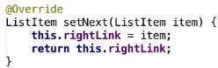   
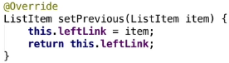  
* We’re returning that reference.  
* Instead of having 2 lines we can do it on 1 line:  
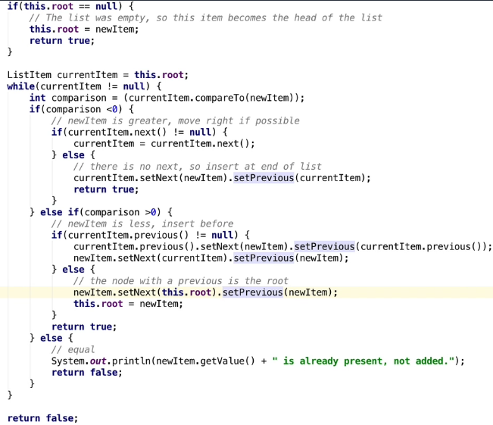  
* Now let’s create a method to go through the list and print the values.  
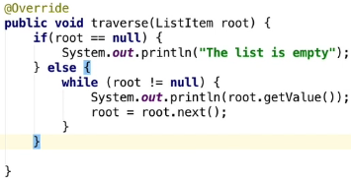  
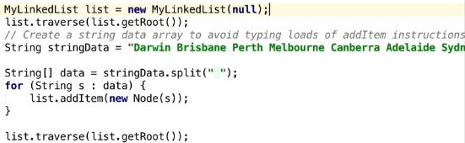 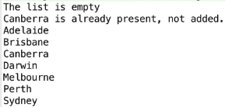

* Now let’s implement the removeItem() method.  
* Removing items is relatively straightforward in a LinkedList. We traverse the list until we find the item to be removed. Then we set the previousLink to point to where our item to be deleted points.  
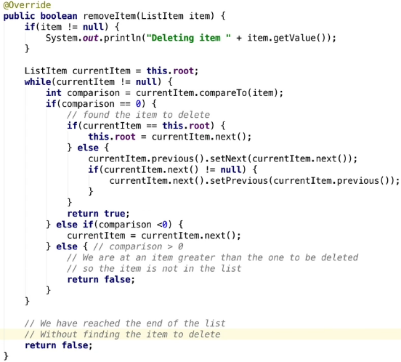

**Abstract Class Challenge Part 3 (including recursion)**  
* **Binary Search Tree**.  
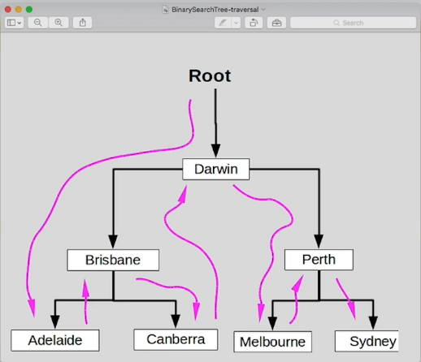  
* Traversing the search tree involves visiting every node to the left, then the root, and then every node to the right in the same way.  
* If we printed the value of every node that we visited rather than passed through, we get the cities in alphabetical order. (note the difference between actually visiting and passing through)  
* Big difference is there is no link back from a child to its parent. So when we get to Adelaide, there’s no way for us to know we got there via Brisbane. This makes an iterative traverse of a Binary Search Tree extremely complicated because we have no direct reference.  
* However, if you look at the tree with Darwin as its root, this is made up of a left tree with Brisbane as its root and a right tree with Perth as its root. So we can then describe Brisnane’s left tree as a tree with Adelaide as its root with no children and the same for Canberra, Melbourne and Sydney.  
=> Therefore a tree can be described as a root with optionally a left tree and a right tree.  
* We’ll talk about the advantages later in this video because it’s actually a very important part of **database management systems** (DBMS).

* There are gonna be differences which are gonna be in the implementation of the addItem(), removeItem() and traverse().  
* addItem() => this has actually got the same structure as in the case of the LinkedList but instead of breaking and recreating links to insert, we’re gonna keep traversing the actual tree itself, so moving left or right as appropriate, until we reach a node that is null.

* Given that we need to continually go back through some of these nodes, we’re gonna write a recursive function.  
* Any definition that includes an object in its own definition, is known as a recursive definition. And objects that can be defined recursively can be processed recursively.  
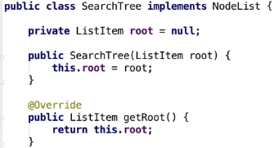

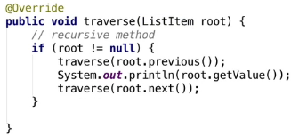  
* Let’s create the addItem() method:  
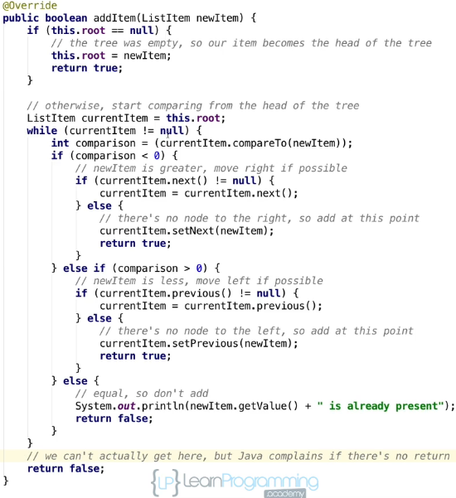  
* It’s got the same structure like it has for the LinkedList but instead of breaking and recreating links to insert, we just keep traversing the tree, moving left or right as appropriate until we reach a node that is null. And once we reach the end of a path through the tree, this becomes the position to insert the new item.

* One consequence of this and this is what I wanted to bring up about the while loop is that the while loop is never going to terminate naturally, so the program’s gonna return out of it, that’s not a problem and the code’s gonna work fine, but the condition we have (currentItem != null) can never actually be false because we’re always checking for null before moving left or right.  
=> **So technically we could have written the code as while (true) and remove the need to have the return false at the end if we wanted to**.  
* But I’ll leave it that because I think it’s more readable, certainly a personal perference there.

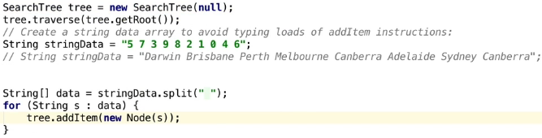

* Just out of interest i’ts actually possible to write a LinkedList recursively as a root followed by LinkedList, so the LinkedList traverse() method could then be rewritten.  
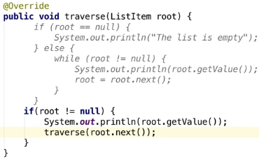  
* It’s that simple, we could actually do that if we wanted to, BUT generally it’s not a good idea to do that due to the depth of the recursion. In other words, how many times it’s calling itself. So a well balanced binary tree with billions of records, billions of nodes, we’d have a maximum depth of around 63 levels. But with a similarly sized LinkedList, it would have to go through the entire LinkedList and the stacks and overflow well before in other words they are going to crash. So you need to make sure that recursive functions are only picked for certain functions and not sort of just used everywhere.  
* For the Binary Search Tree it’s actually optimized for that and even for that large number of records it still is only gonna be in the maximum 63 deep which will be fine for most platforms that are running in Java.

* Now let’s create the removeItem(), this is what it looks like for a LinkedList.  
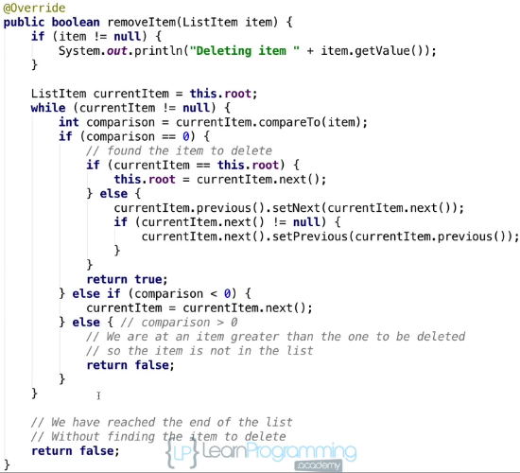  
* First off, we need to think that if the item to be removed has no children, then the link to it can be set to null. If the item to be removed has 1 child and it’s either pointing left or right, then removal is just the case of setting the item’s parent to point to the child again. That’s pretty straigh tforward again.   
* The big scenario is if the item to remove has both a left and a right child, then removal is not that easy because we need to ensure that every node to the left and every node to the right is greater than its parent. There’s actually an algorithm to do that.

* For the item to be deleted we move to the right sub tree and we keep traversing left until we reach a node with no left child. This is then the smallest value in the right sub tree. Then we set the value of the node to be deleted to the smallest value and everything to the left is already smaller than that, and as a result, this is the smallest value to the right side tree and everything to the right is greate than it. And we finish off by removing the smallest node which is easy as it’s got either no children, or only has a right child. Note that we’re not actually removing the item to be deleted, we just set the value of that to another node and we actually remove the other node. So this method’s basically traversing the tree, moving right or left as appropriate until it finds the item to be deleted. And before the actual current items are advanced in the appropriate direction, left or right, the parent item reference is set to point to it, and we’re doing it that way so that it eventually finds the item to be deleted and we can also have a reference towards its parent. So this is only determining the items to be removed.  
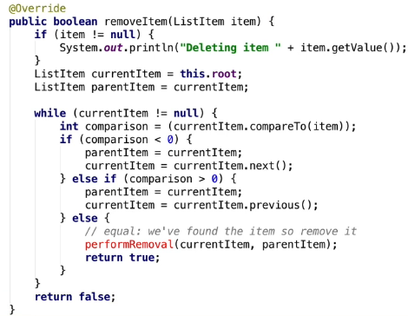  
* The actual code to remove the item is actually quite big. It’s quite detailed as you can see and I’m gonna talk about one of the ways that DBMSs get around this to keep performance high.  
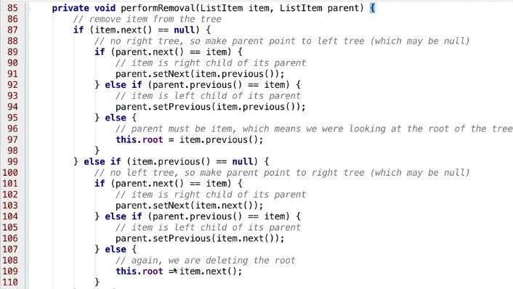  
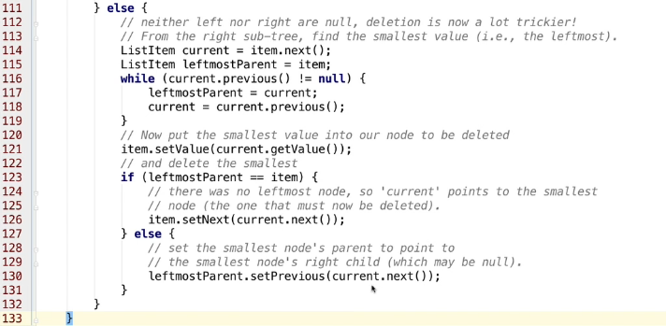

* Removing item is lot more complicated in Binary Search Trees and a lot of Database Management Systems that actually use Binary Search Trees, they don’t actually delete the record straight away so they’re often flagged as being deleted, which means it’s just like a flag set in the record and they’re actually ignored in the searches and queries as a result of that. And the actual deletion, the physical dleetion of the actual data only occurs perhaps during out-of-hours maintenance procedures, you know, recompacting or reindexing the database. Because you can imagine with all this code, it there’s hundreds or thousands or millions of records, it’s going to take a long time to process.  
* Part of becoming a good programmer is learning the best solutions or best code to tackle a particular solution, and that will come over time and with more experience.